ITEM DETAILS
Name of Item | Inter-War House Flats
Other Name/s  Former Name/s | 25 Denham Street, Bondi
Item type | Built
Item group | Flat Building
Item category | Flat
Area, Group, or Collection Name | Unknown
Street number | 25
Street name | Denham Street
Suburb/town | Bondi |  |  |  |  | Postcode |  |  | 2026
Local Government Area/s | Waverley
Property description | Lot 1 DP 105041
Location - Lat/long | Latitude | -33.894558 |  | Longitude | 151.268818
Location - AMG (if no street address) | Zone |  |  | Easting |  |  |  | Northing
Owner | Private
Current use | Residential
Former Use | Residential
Statement of significance | 25 Denham Street, Bondi (c1934) is a distinctive and intact example of a two-storey Inter-War Spanish Mission flat building in Waverley. The original use of the building as a doctor’s surgery demonstrates the growth of the community and the development of Bondi Road, a major road and major tram route, in the Inter-War period. The building represents the development of Inter-War flat buildings, an important phase in the history of Waverley which represents the 1920s-1930s development boom, a prominent period of economic prosperity and speculative development in Waverley associated with the changing demographics with a shift to living in flats.  Despite being well represented in other local government areas, it is a rare example of the Inter-War Spanish Mission style in Waverley.
Level of Significance | National |  | State |  |  |  | Local

DESCRIPTION
Designer

Builder/ maker

Physical Description | 25 Denham Street, Bondi is a two-storey flat building that dates from the Inter-War period, later than the key period of significance of the Warnock subdivision. The building displays features of the Inter-War Spanish Mission style including medium pitch gabled roof, Spanish/Roman roof tiles, stucco with exaggerated texture, shaped corbel, grouped arched openings and barley twist columns. The building is setback 4 metres from the street on a corner site approximately 11 metres wide, that reflects the original subdivision pattern within a retail strip setting that has retained its historic context.  The site has a fence of textured brick with rendered capping and arched entry on Bondi Road approximately 1.5 metres high, which compliments the setting of the place, but has been modified. The site also features a garage and subsidiary buildings which are of similar date and style and compliment the setting of the place. The site is informally landscaped and features a curved path and lawn and provides an appropriate setting for the building. The building is in good condition and substantially intact.  Elements impacting upon the integrity of the site include the loss of original detail to the fence to Denham Street which was reconstructed c.2016 and Verandah/balcony infill.
Physical condition  and  Archaeological potential | The building appears to be in good condition
Construction years | Start year |  | Finish year |  | Circa | c1934
Modifications and dates | Front fence modified 2016.

HISTORY
Historical notes | 25 Denham Street, Bondi, was part of O’Brien’s Homestead holding and its carriage-way entrance, originally a large lot fronting Bondi Road (then Waverley Street) extending to Edward Street. It was resubdivided as the Warnock subdivision by T.O. and A.J. O’Brien under DP 3635. The subject site is a resubdivision of Lots 1 and 2 which fronted Bondi Road. Lot 2 was purchased by Joseph Adophus Flanagan, a draper of Bondi, in June 1900. Lot 1 was purchased by physician Richard Wallace in 1903. Wallace amalgamated the site but was bankrupted in 1908. Builder David Stewart purchased part of Lots 1 and 2 including the site in 1909. He subdivided his holding into 3 portions. Elizabeth Meagher, wife of Martin Phillip Meagher, a chemist of Sydney, purchased the corner lot in 1911. The property changed hands several times in 1914, 1915, 1921 and 1934. Based on the popularity of the Spanish Mission style, it is likely the flats were built c1934 by John Hardie, medical practitioner, who bought the property in 1934, or by his predecessor Leslie Ewart Senis Larbelestier, also a medical practitioner. In 1956, it was sold to another medical practitioner, Isaac Segal. The front fence was modified c.2016 (refer Google Images).

THEMES
 | National historical theme | 3 Developing local, regional and national economies  4 Building settlements, towns and cities  8 Developing Australia’s Cultural Life
 | State  historical theme | Transport  Towns, suburbs and villages  Accommodation  Creative endeavour
 | Local  historical theme | Traffic and Transport  Flats and Bungalows  Community

Assessment
A: Historical Significance | 25 Denham Street, Bondi has historical significance at a local level as it represents the development of Inter-War flat buildings, an important phase in the history of Waverley, which represents the 1920s-1930s development boom, a prominent period of economic prosperity and speculative development in Waverley associated with the changing demographics with a shift to living in flats.  The original use of the building as a doctor’s surgery demonstrates the growth of the community and the development of Bondi Road, a major road and major tram route, in the Inter-War period.  25 Denham Street, Bondi has historical significance at a local level as it demonstrates the preference for Spanish Mission style in Bondi and Waverley from 1929.
B: Associative | To date no historic association has been identified.
C: Aesthetic significance | 25 Denham Street, Bondi, has aesthetic significance at a local level as a distinctive and intact example of a two-storey Inter-War Spanish Mission-style flat building prominently located in a retail strip.  The building shows an accomplished use of the Inter-War Spanish Mission style, evident in features including the medium-pitch gabled roof, pan roof tiles, stucco with exaggerated texture, shaped corbel, grouped arched openings and barley twist columns.
D: Social significance | To date no social, cultural, and spiritual significance has been identified.
e) Technical/  Research significance | To date no research/technical significance has been identified.
f) Rarity | 25 Denham Street has rarity significance at a local level as it is a rare example of the Inter-War Spanish Mission style in Waverley, despite being well represented in other local government areas.
g) Representative-ness | 25 Denham Street has representative significance at a local level as a distinctive and intact example of an Inter-War Spanish Mission flat building in Waverley that reflects the development of Bondi Road in the Inter-War period.
Integrity | The building is substantially intact.

HERITAGE LISTINGS
Heritage listing/s | Draft Waverley LEP 2012

INFORMATION SOURCES
Type | Author/Client | Title | Year | Repository
 | Waverley Council | Waverley Heritage Policy | 2007
 | Waverley Council | Waverley Heritage Study | 1993
 | Perumal Murphy Pty Ltd | Waverley Heritage Study | 1990
 |  | Certificate of Title Vol 36 Fol 195 |  | NSW Land Registry Services
 |  | Certificate of Title Vol 1325 Fol 152 |  | NSW Land Registry Services
 |  | Certificate of Title Vol 1494 Fol 200 |  | NSW Land Registry Services
 |  | Certificate of Title Vol 2001 Fol 155 |  | NSW Land Registry Services
 |  | Certificate of Title Vol 2116 Fol 158 |  | NSW Land Registry Services
 |  | DP 3635 |  | NSW Land Registry Services

RECOMMENDATIONS
Recommendations

SOURCE OF THIS INFORMATION
Name of study or report | Heritage Policy by Waverley Council reviewed by Architectural Projects 2023 |  | Year of study or report
Item number in study or report

Author of study or report
Inspected by
NSW Heritage Manual guidelines used? |  |  |  | Yes |  | No
This form completed by |  | Architectural Projects 2023 |  | Date

IMAGES

Image caption | 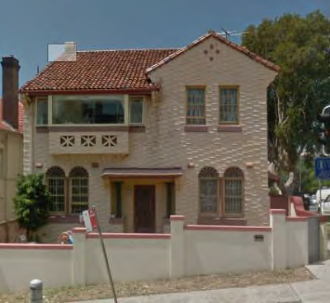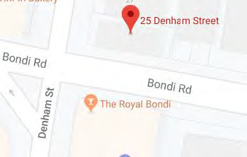
Image year |  | Image by | Google Maps | Image copyright holder

Image caption:  Early  Subdivision plan for the O’Brien Estate at Bondi. Denham Street once formed the carriage-way into the family estate. | 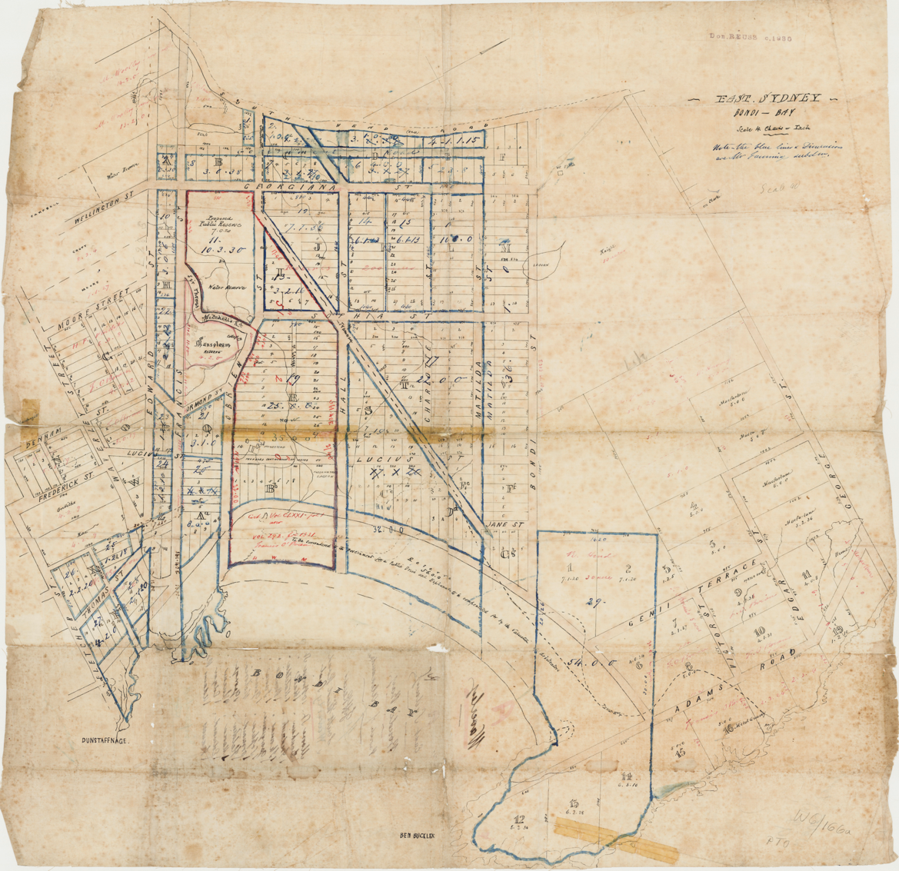
Image year | Undated | Image by | State Library of New South Wales | Image copyright holder

Image caption | 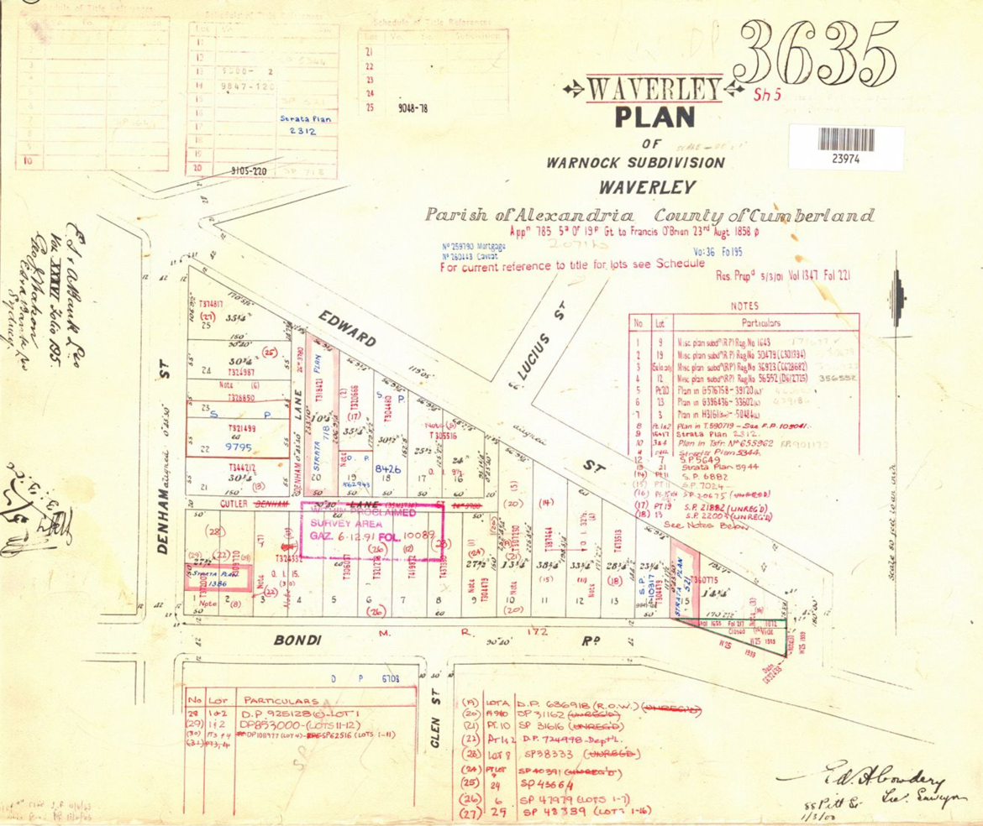
Image year | Undated | Image by | LPI | Image copyright holder

Image caption | 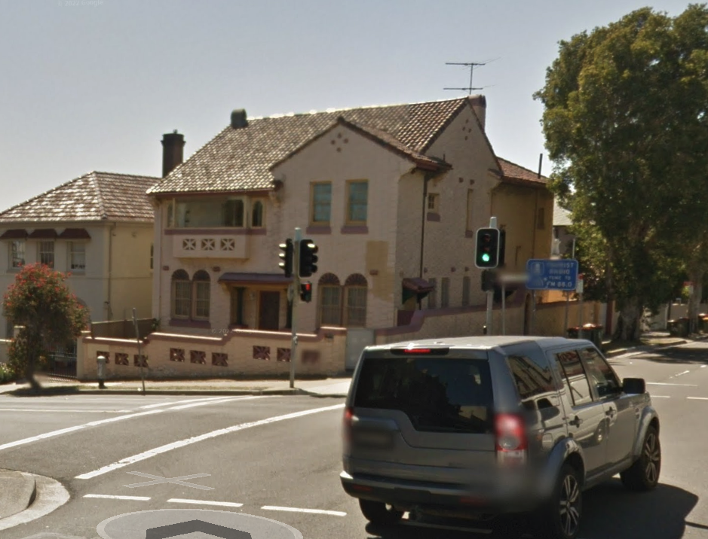
Image year | 2015 | Image by | Google Maps | Image copyright holder

Image caption | 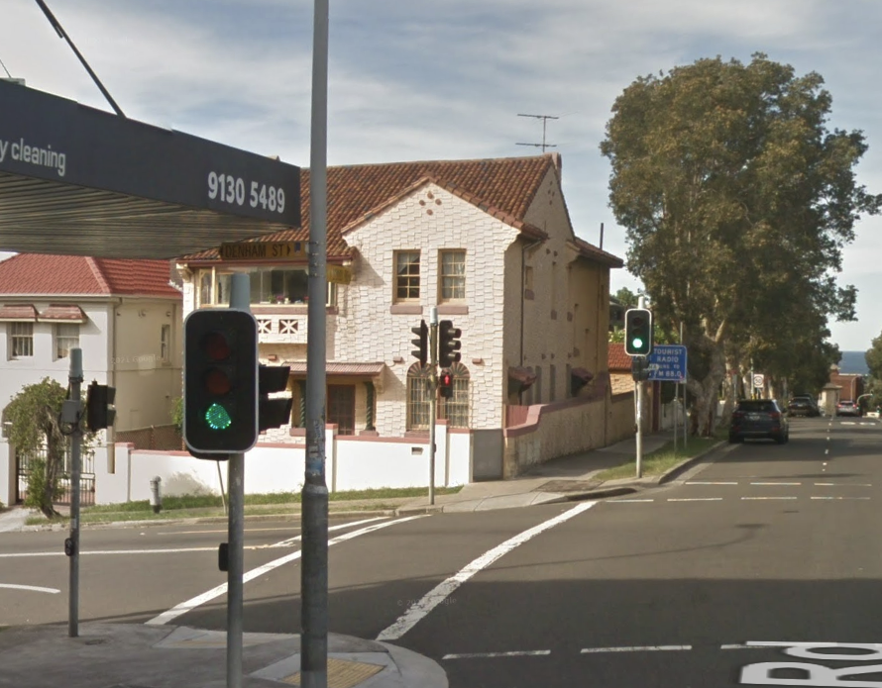
Image year | 2016 | Image by | Google Maps | Image copyright holder

Certificate of Title Vol 36 Fol 195
DP 3635
Certificate of Title Vol 1325 Fol 152
Certificate of Title Vol 1494 Fol 200
Certificate of Title Vol 2001 Fol 155
Certificate of Title Vol 2116 Fol 158
Certificate of Title Vol 2116 Fol 158

